*users test*

tested prototypes

test drivers

*output*

evaluate design

plan + code

implementation

*realistic TCs*

*trial run: similar work conditions*

*software s.t user needs*

*test software incrementally*

Test code

Code Testing

**Unit testing**: each module (in solation), can re-use test drivers

(esp. top-down plan)

**Integration testing**: a group of modules 🡨 unit test procedure

can use top-level modules

**Regression testing**: each modification 🡪 re-run tests

(error correction)

* ensure code integrity

Test Driver design

organise -> type hierarchies 🡪 Reuse

Engine

share common test objects

combine

drivers

each test driver

🡪 a unit test

enhance

re-use + automation

support modular test design

a series of test drivers

Test suite

test drivers created 🡪 each KEngine version

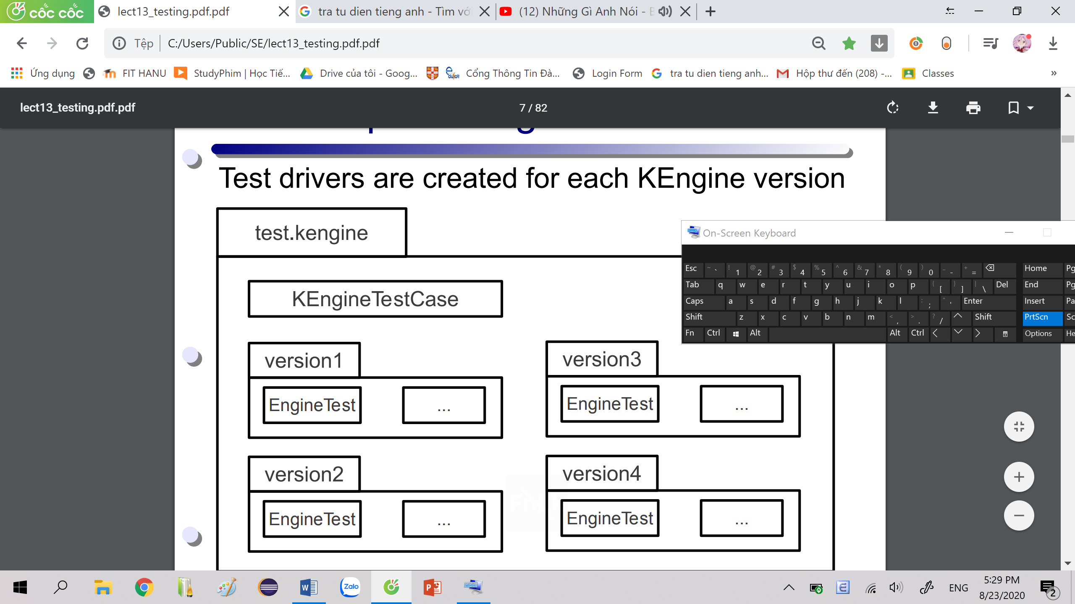

Test Iteration 1

Core class: Doc Comm Engine

Stub class: Helpers Query TitleTable WordTable

|  |
| --- |
| DocTestTitle |
|  |
|  |

Test driver hierarchy

|  |
| --- |
| DocTest |
|  |
|  |

|  |
| --- |
| CommTest |
|  |
|  |

|  |
| --- |
| KEngineTestCase |
|  |
| getTestDir()  print()  printError()  assertArrayEquals |

|  |
| --- |
| EngineTest |
|  |
| testEngine()  testDocs() |

|  |
| --- |
| EngineTestDocs |
|  |
| testDocs() |

|  |
| --- |
| EngineTestMain |
|  |
| testEngineMain() |

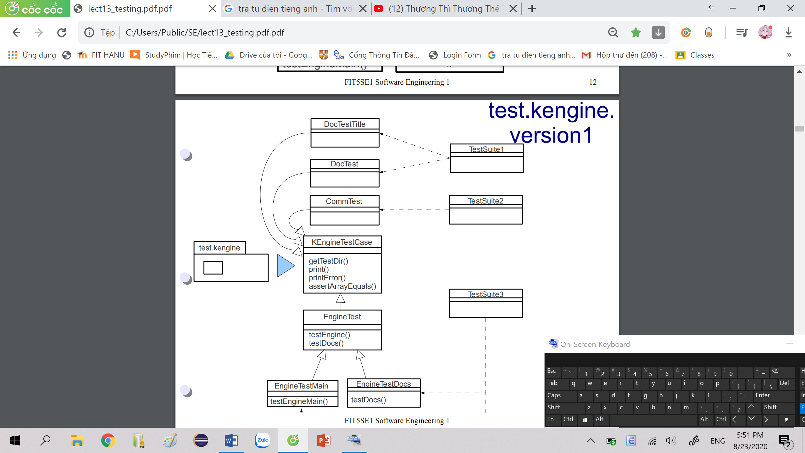

Engine Doc Comm

Unit Testing

Engine

test method: Engine()

considers others: stubs

test driver: EngineTestMain

Doc

|  |
| --- |
| Doc |
|  |
| Doc(String)  title(): String  body(): String  words(): Iterator |

TCs: Doc(String) Dooc.title()

Doc(String) Doc.body() Doc.words()

Gr1: TCs : docs, titles: one of following cases

* null: ~~<title></title>~~ (tags)
* empty (“”): <title></title>
* single char: <title>a</title>
* a proper string:

<title>” welcome to my page “</title>

Gr2: TCs: docs, body text: one of following cases

* null: ~~<body></body>~~ tags
* empty (“”): <body></body>
* only tags: <body><p></body>
* no tags: <body>some text</body> ~~<p>~~
* simple tags: <body><p>some text</body>
* complex tags:

<body><p> <span …>some text</span></body>

Test Drivers:

Gr1: DocTestTitle.java

Gr2: DocTest.java

Test suite: TestSuite1

Comm

input String: valid folder path URL

/home/duclm/data/sites/hanu

TCs: U(valid) u(invalid)

* null
* empty String“”
* incorrect path

u1 = /home/duclm/data/sites/void

* correct path

U1 = /home/duclm/data/sites/hanu

Test Driver: CommTest

Test suite: TestSuite2

Integration Testing

|  |
| --- |
| Engine |
|  |
| Engine()  queryFirst(String): Query  queryMore(String): Query  findDoc(String): Doc  **addDocs(String): Query** |

Engine.addDocs: Doc Comm

|  |
| --- |
| Comm |
|  |
| getDocs(): Iterator |

|  |
| --- |
| Doc |
|  |
| Doc(String)  title(): String  body(): String  words(): Iterator |

TCs: addDocs = Comm.getDocs() + {U1} (duplicate URL check)

Test driver: EngineTestDocs

Test suite: TestSuit3



Test iteration 2

Helpers: common procedures 🡪 other classes

canon()

TitleTable: keep track of documents + titles

Test Driver hierarchy

|  |
| --- |
| EngineTestDocs |
|  |
| testDocs() |

|  |
| --- |
| EngineTestFind |
|  |
| testFind()  addDocs() |

|  |
| --- |
| version1.EngineTest |
| #docURLs: String[]  #docResults: Object[]  #titles: String[]  #titleResults: boolean[] |
|  |

|  |
| --- |
| EngineTest |
|  |
| testEngine() |

|  |
| --- |
| EngineTestMain |
|  |
| testEngineMain() |

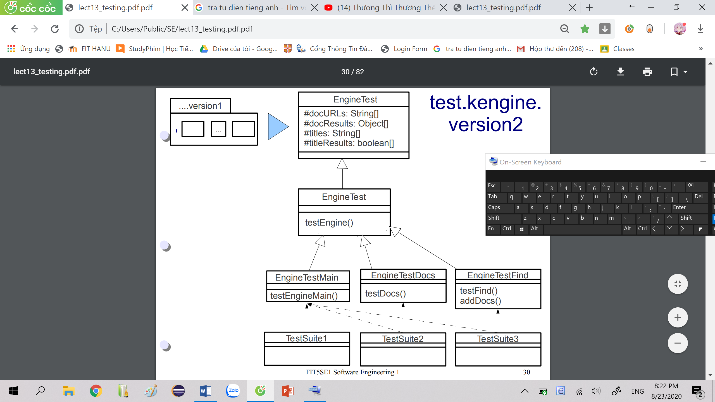

Engine Helpers

Unit Testing

Test Driver: EngineTestMain

tests version2.Engine

Test suite: TestSuite1

|  |
| --- |
| Helpers |
|  |
| canon(String): String |

Helpers

BBT (black box test cases):

* null
* empty String (“”)
* single-char String: “a”
* normal Strings: “some text”

GBT (white box test cases):

* null
* not null: same as those for String.toLowerCase()
* skipped

TCs fall into one of GBT

Integration Testing

|  |
| --- |
| Engine |
|  |
| Engine()  queryFirst(String): Query  queryMore(String): Query  **findDoc(String): Doc**  **addDocs(String): Query** |

Engine.addDocs 🡪 TitleTable.addDoc + Helpers.canon

Engine.findDoc 🡪 TitleTable.lookUp + Helpers.canon

|  |
| --- |
| TitleTable |
| Hashtable docs |
| TitleTable()  **addDoc(Doc)**  **lookUp(String): Doc** |

|  |
| --- |
| Helpers |
|  |
| **canon(String): String** |

TitleTable TCs

*Gr1*: TitleTable() 🡪 a new empty table

addDoc() 🡪 a new <t, doc> entry

Engine.addDocs 🡪 TitleTable.addDoc

TCs: T(valid title) t(invalid title)

duplicate check: {T1, T1}

valid URL U1: 3 documents {d1, d2, d3}

d2.title = d3.title

Test Driver: EngineTestDocs

Test suite: TestSuite2

*Gr2: Gr1* 🡪 new entries

lookUp() 🡪 verifies inserted entries

Engine.findDoc 🡪 Title.lookUp

TCs: {null, “”, t1, T1}

Test Driver: EngineTestFind

Test suite: TestSuite3



Test Iteration 3

*DocCnt*<Doc, count>

count: word frequency of some words in Doc

*WordTable*<String, Vector<DocCnt>>

keyword – DocCnt objects vector (contain)

Extra methods:

*Engine(String):* custom properties file

🡪 initialises a new Engine

*getWords:* check all words

*getNonKeys:* check all non keys

|  |
| --- |
| Engine |
|  |
| Engine()  **Engine(String)**  queryFirst(String): Query  queryMore(String): Query  findDoc(String): Doc  addDocs(String): Query  **getWords(): String[]**  **getNonKeys(): String[]** |

*WordTable(String):* custom nk.dat file

🡪 initialises a new WordTable

|  |
| --- |
| WordTable |
| Hashtable table |
| WordTable()  **WordTable(String)**  isInteresting(String): boolean  lookUp(String): Vector  addDoc(Doc): Hashtable |

|  |
| --- |
| version1.EngineTest |
| #docURLs: String[]  #docResults: Object[]  #titles: String[]  #titleResults: boolean[] |
|  |

|  |
| --- |
| EngineTest |
|  |
| testEngine()  addDocs() |

|  |
| --- |
| EngineTestMain |
|  |
| testEngineMain() |

|  |
| --- |
| EngineTestWordTable1 |
|  |
|  |

|  |
| --- |
| EngineTestWordTable2 |
|  |
|  |

|  |
| --- |
| EngineTestLookUp |
|  |
|  |

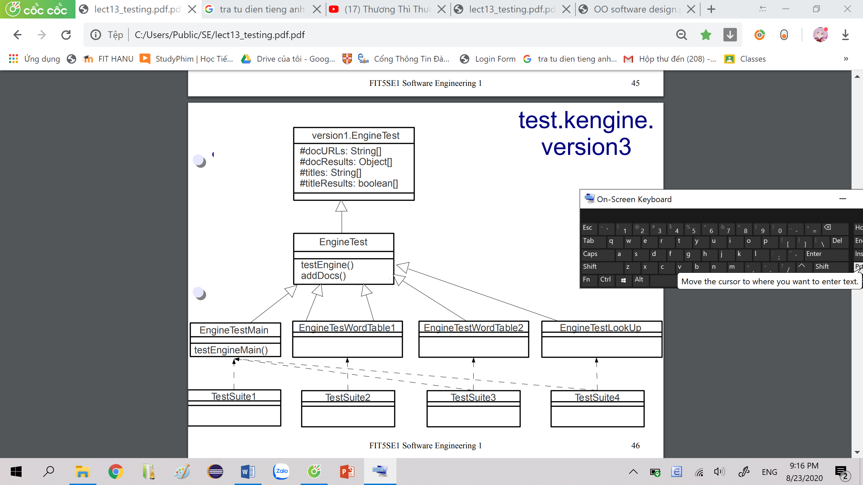

Engine DocCnt

Unit Testing

Engine

|  |
| --- |
| EngineTestMain |
|  |
| testEngineMain() |

Test method: Engine()

Test Driver: EngineTestMain

Test suite: TestSuite1

DocCnt

|  |
| --- |
| DocCnt |
| Doc d  int cnt |
| DocCnt(Doc, int)  getDoc(): Doc  getCount: int  toString(): String |

rep + getters

TC + driver:

valid 🡪 Doc objects + counts

TestDriver: DocCnt objects 🡨 test data

invoke getters 🡪 check results

Integration Testing

|  |
| --- |
| WordTable |
| Hashtable table |
| WordTable()  WordTable(String)  isInteresting(String): boolean  lookUp(String): Vector  addDoc(Doc): Hashtable |

~~test isInteresting()~~

local context

invoked only by addDoc()

Gr1: *WordTable(String)*

BBT:

* nk-file not exist
* nk-file exist: canonical test - words

(different cases)

GBT: nk-file exist

* nk-file: empty
* nk-file: single word
* nk-file: 2 or more words

Test Driver: EngineTestWordTable1.java

Engine(String) Engine.getNonKeys()

Test suite: TestSuite2

Gr2: *Gr1* (WordTable(String)) + *addDoc*

BBT:

* d: (some) interesting words
* d: interestings in different cases

GBT:

* d: ~~words~~
* d: ~~interesting~~
* d: some distinct interestings
* d: repetitive interestings

Test Driver: EngineTestWordTable2.java

Engine.addDocs Engine.getWords()

Test suite: TestSuite3

Gr3: *Gr2* (WordTable(String), addDoc) + *lookUp*

BBT:

* k: an interesting word
* k: uninteresting
* k: non-word

Test Driver: EngineTestLookUp.java

Engine.addDocs Engine.queryFirst

Test suite: TestSuite4

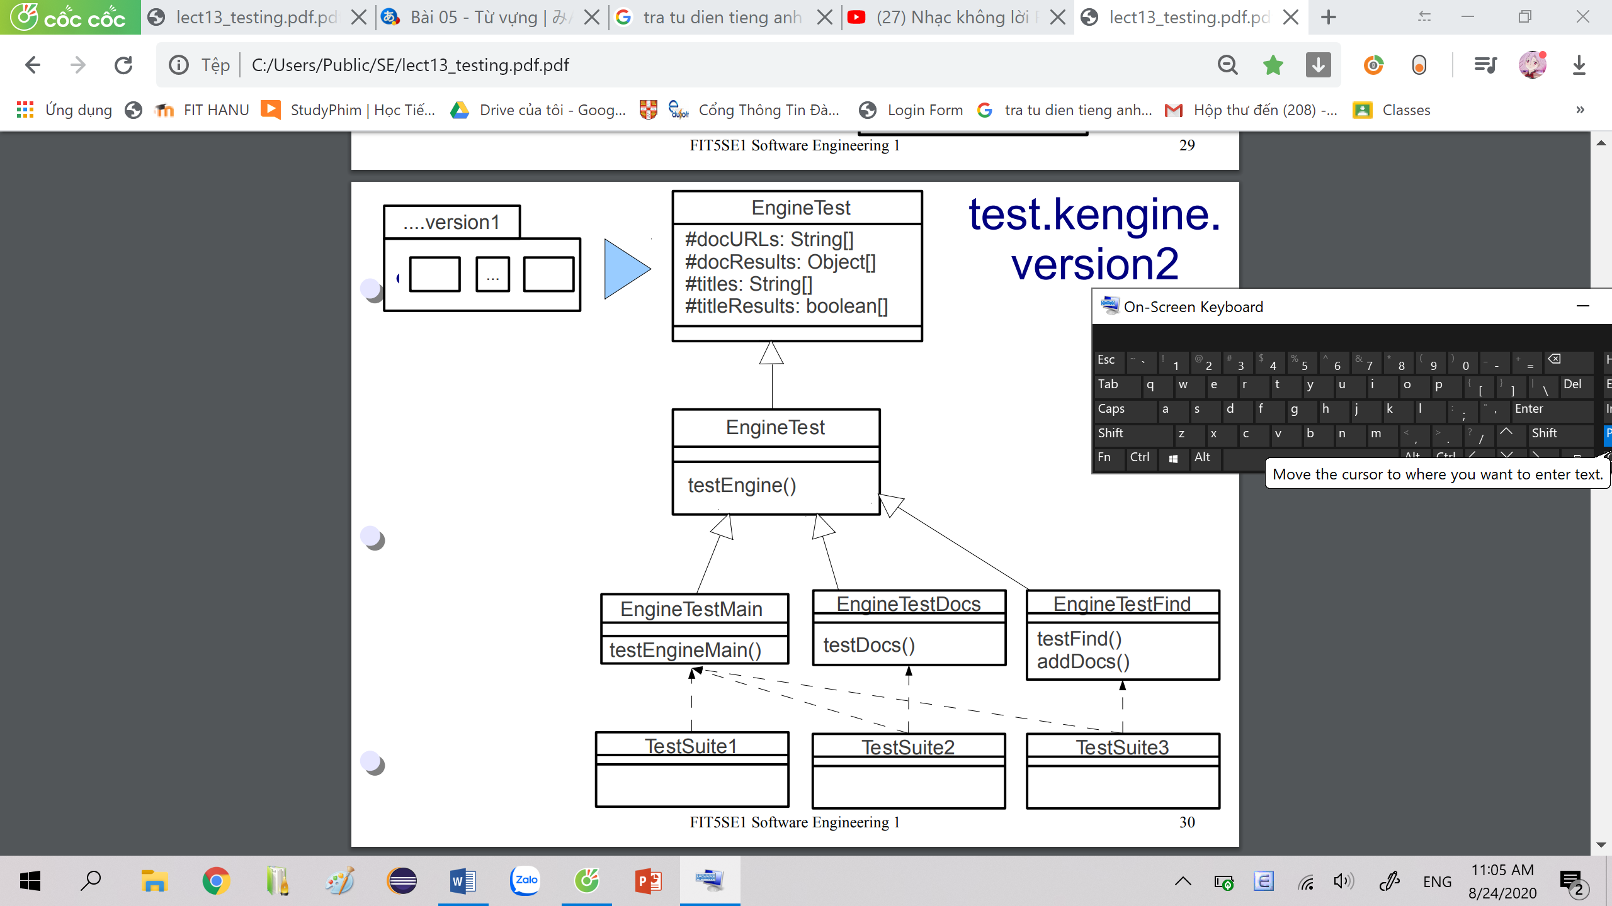

Test Iteration 4

Query: full query logic

Engine: queryFirst queryMore addDocs

Sorting + DocCnt:

implement

DocCnt Comparable (interface)

sort

* quickSort(Vector) DocCnt objects Vector

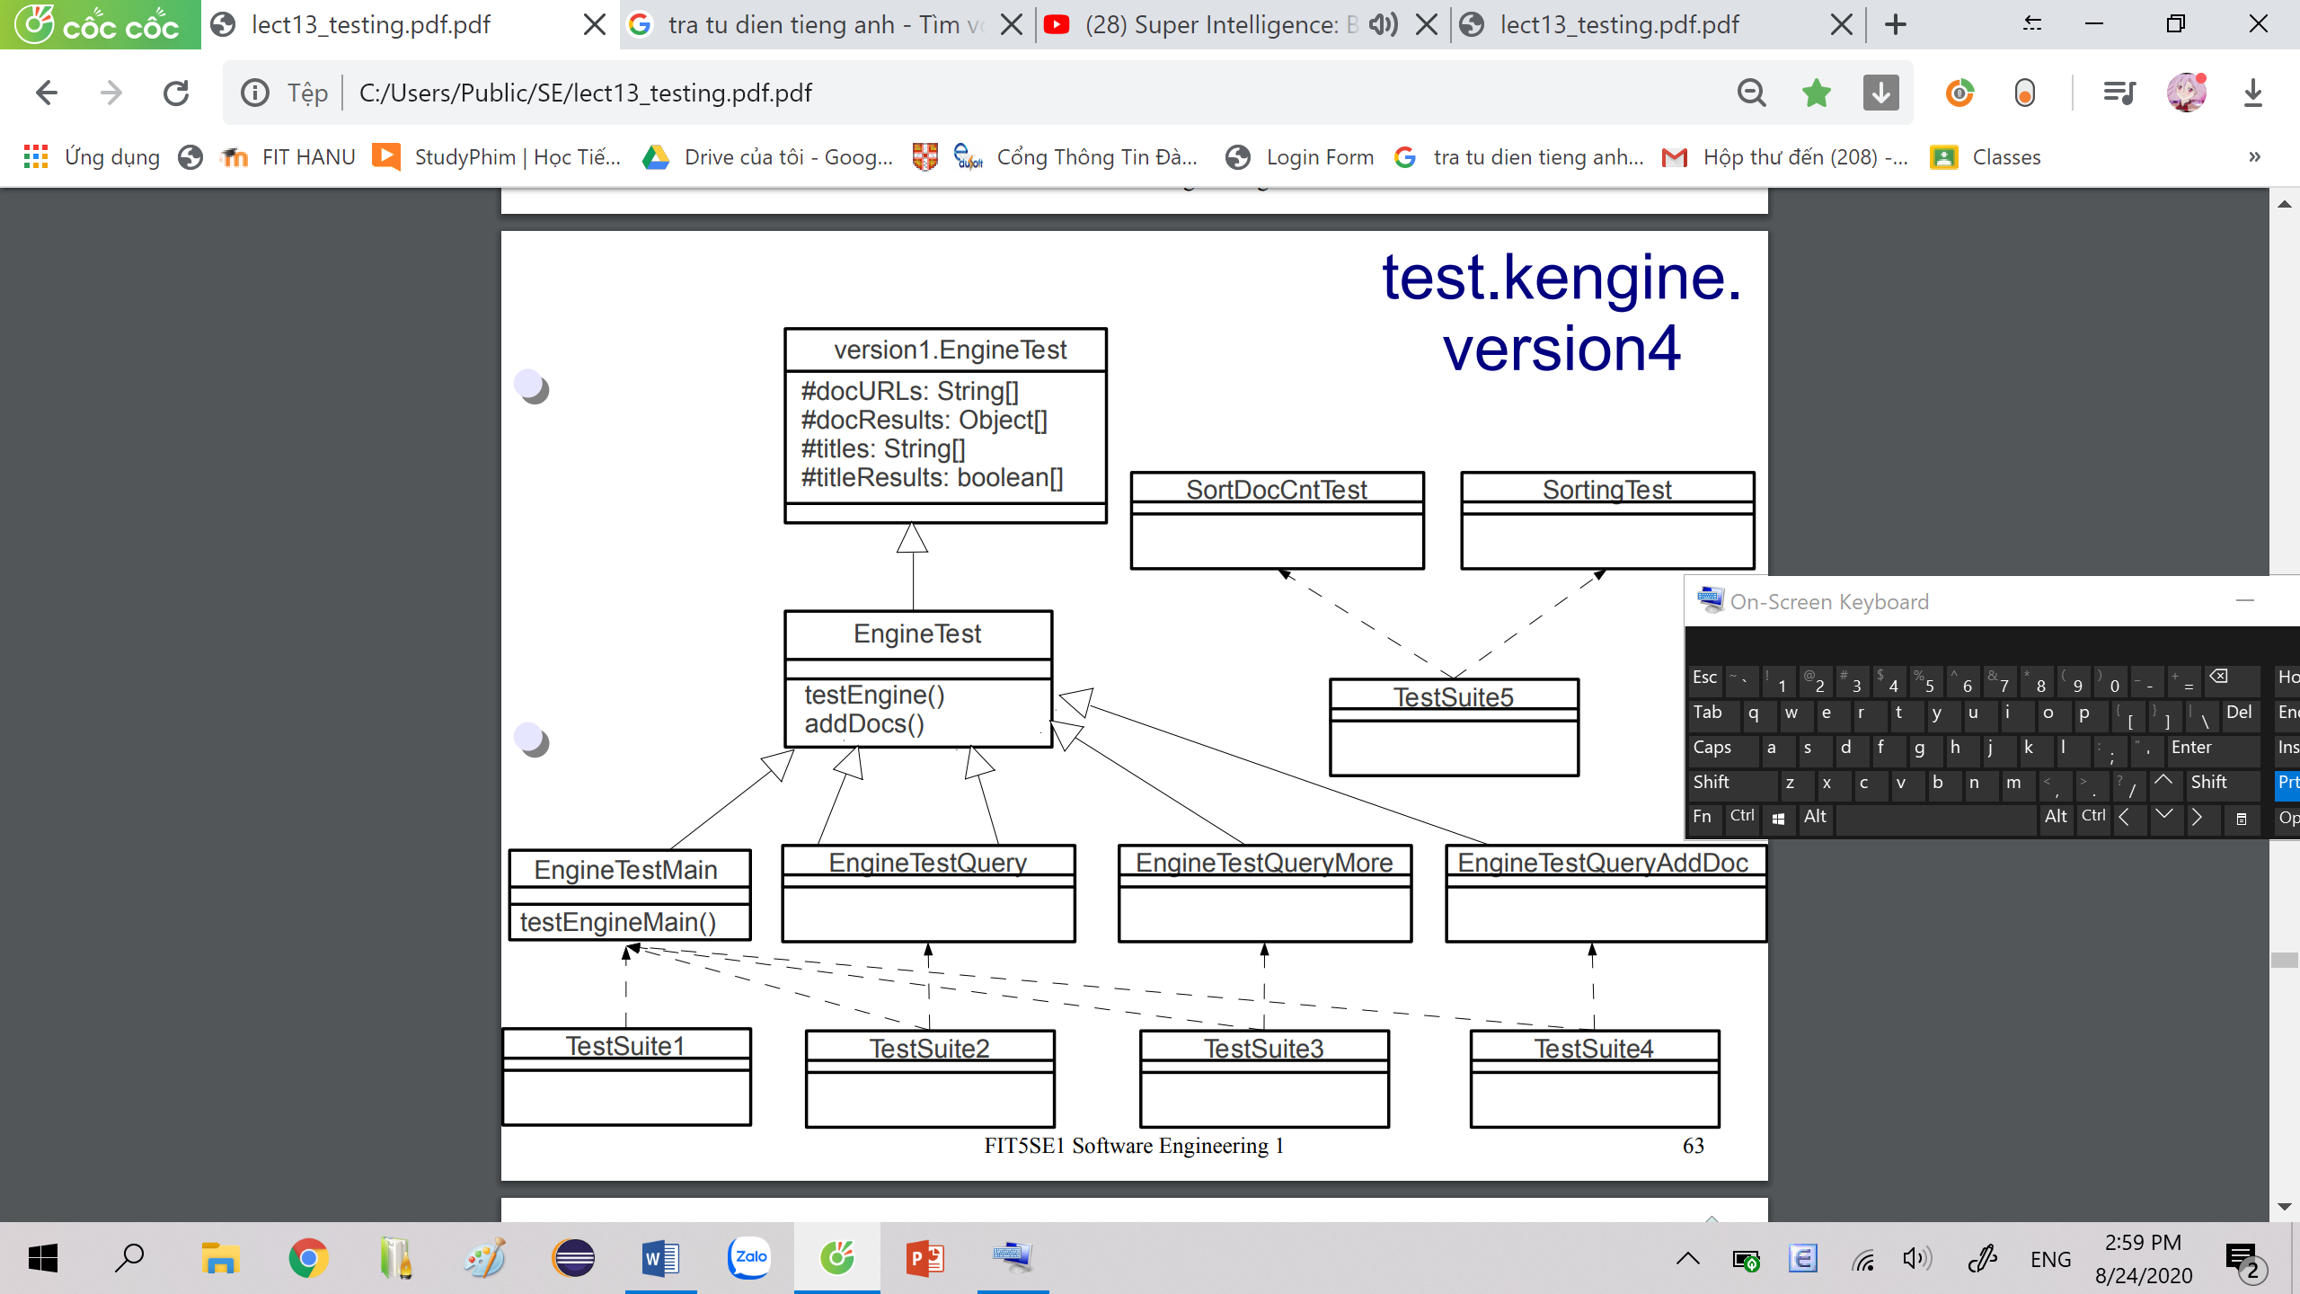

Unit Testing

Engine Sorting

Engine

constructor Engine()

Test Driver: EngineTestMain

Test suite: TestSuite1

Sorting

|  |
| --- |
| Sorting |
|  |
| quicksort(Vector) |

Test method: quicksort(Vector)

Test Driver: SortingTest

Integration Testing

Query & Engine Sorting & DocCnt

Query & Engine

use same set of Test Drivers 🡪 Engine + Query

|  |
| --- |
| Engine |
|  |
| Engine()  **queryFirst(String): Query**  **queryMore(String): Query**  findDoc(String): Doc  **addDocs(String): Query** |

|  |
| --- |
| Query |
|  |
| Query()  **Query(WordTable, String)**  keys(): String[]  size(): int  fetch(): Doc  **addKey(String)**  **addDoc(Doc, Hashtable)** |

keys(): toString() 🡪 results

size() & fetch(): all groups 🡪 verify test results

Engine.queryFirst 🡪 Query(WordTable, String)

Engine.queryMore 🡪 Query.addKey()

Engine.addDocs 🡪 Query.addDoc()

Gr1: *Query(WordTable, String)*

TCs 🡪 Engine.queryFirst() + Query(WordTable, String)

* w: a keyword (table)
* w: invalid word (~~table~~)
* w: non-interesting

Test Driver: EngineTestQuery.java

* Engine.queryFirst

Test suite: TestSuite2

Gr2: *Gr1*(Query(WordTable, String) + *addKey*

addKey TCs:

* w: an existing keyword
* w: new keyword

Engine.queryMore additional TCs:

* w: an invalid word
* w: non-interesting

Test Driver: EngineTestQueryMore.java

🡨 Engine.queryFirst + Engine.queryMore

Test suite: TestSuite3

Gr3: *Gr2*(Query(WordTable, String), addKey) + *addDoc*

addDoc TCs:

* d: ~~query~~ ~~keywords~~
* d: 1 of query keywords
* d: all query keywords

Test Driver: EngineTestQueryAddDoc.java

🡨 Engine.queryFirst queryMore addDocs

Test suite: TestSuite4

Sorting & DocCnt

TC: a Vector 🡪 (some) DocCnt objects

Test Driver: SortDocCntTest.java

Test suite: TestSuite5



Tested Code

KEngine

nt.dat

NotImplementedException

DuplicateException

NotPossibleException

Helpers

Sorting

Comm

DocCnt

Query

Doc

TitleTable

WordTable

Engine